**Project Report Template**

1. **INTRODUCING**
   1. **Overview**

This report delves into the captivating realm of India's agricultural cultivation, providing a comprehensive visual exploration of key aspects and trends in the agricultural sector. Through the visual representations, readers can gain valuable insights into crop production, seasonal variations, regional distribution, and overall production trends.

* 1. **Purpose**

Through the visual representations, readers can gain valuable insights into crop production, seasonal variations, regional distribution, and overall production trends. These visualizations enable intuitive analysis, allowing stakeholders to uncover patterns, identify areas of growth or concern, and make data-driven decisions.

**2 PROBLEM DEFINITION & DESIGN THINKING**

**2.1 Empathy Map**

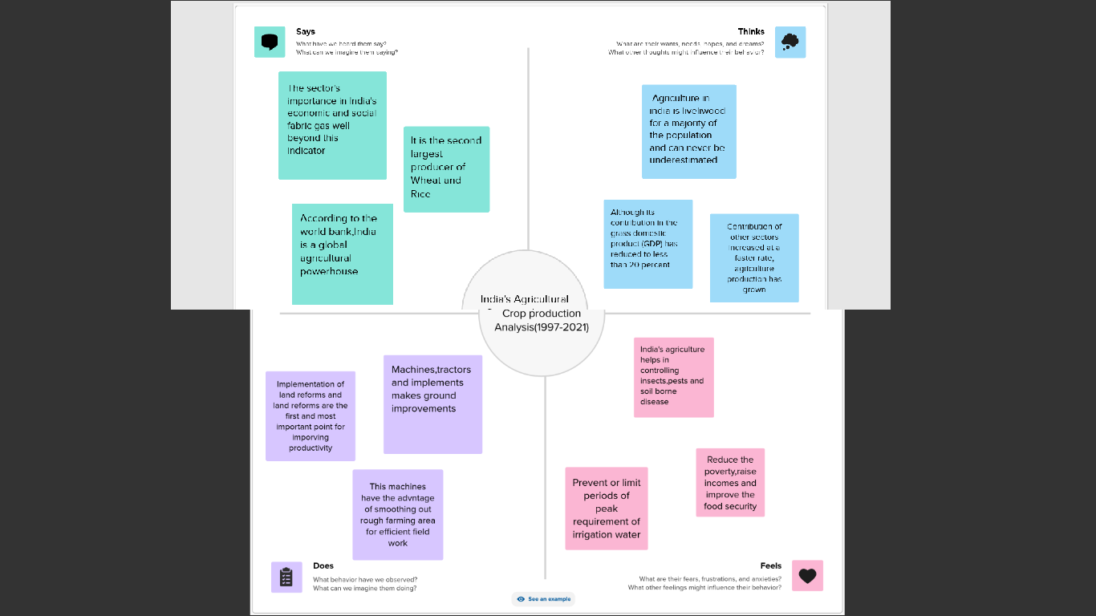

* 1. **Ideation & Brainstorming Map**

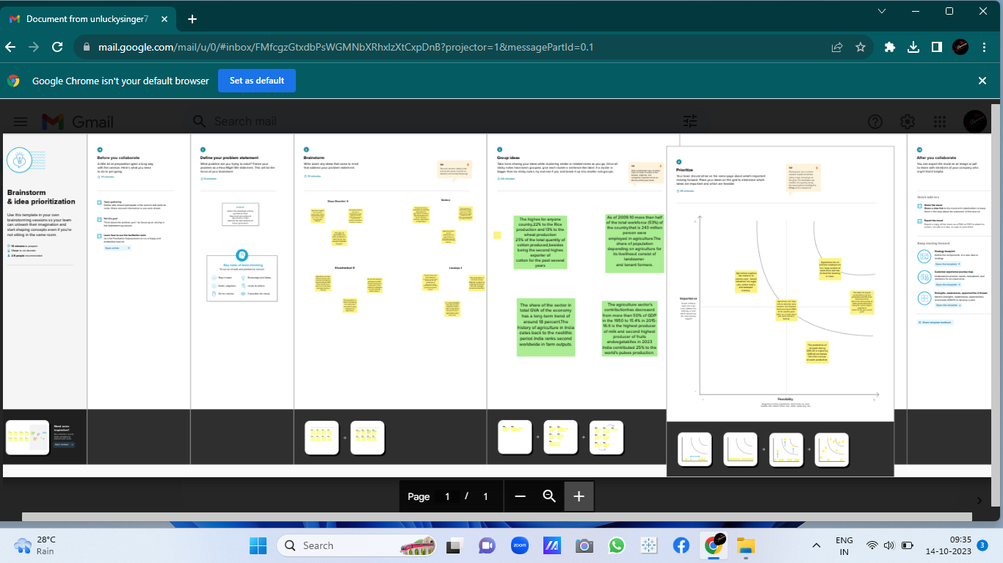

1. **RESULT**

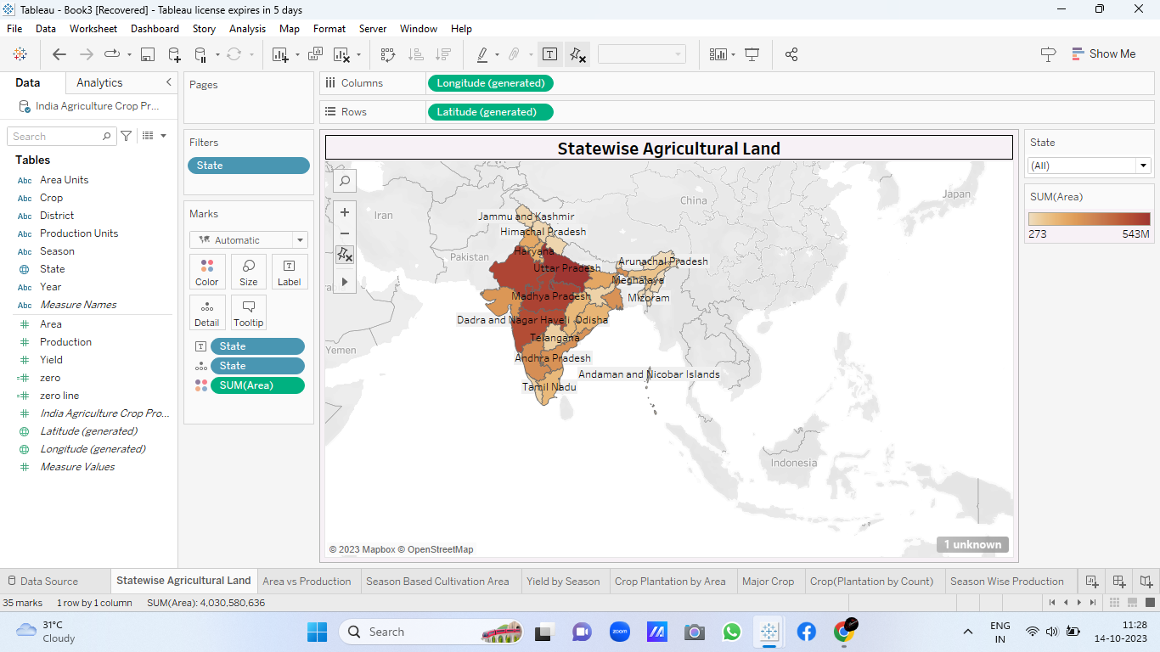

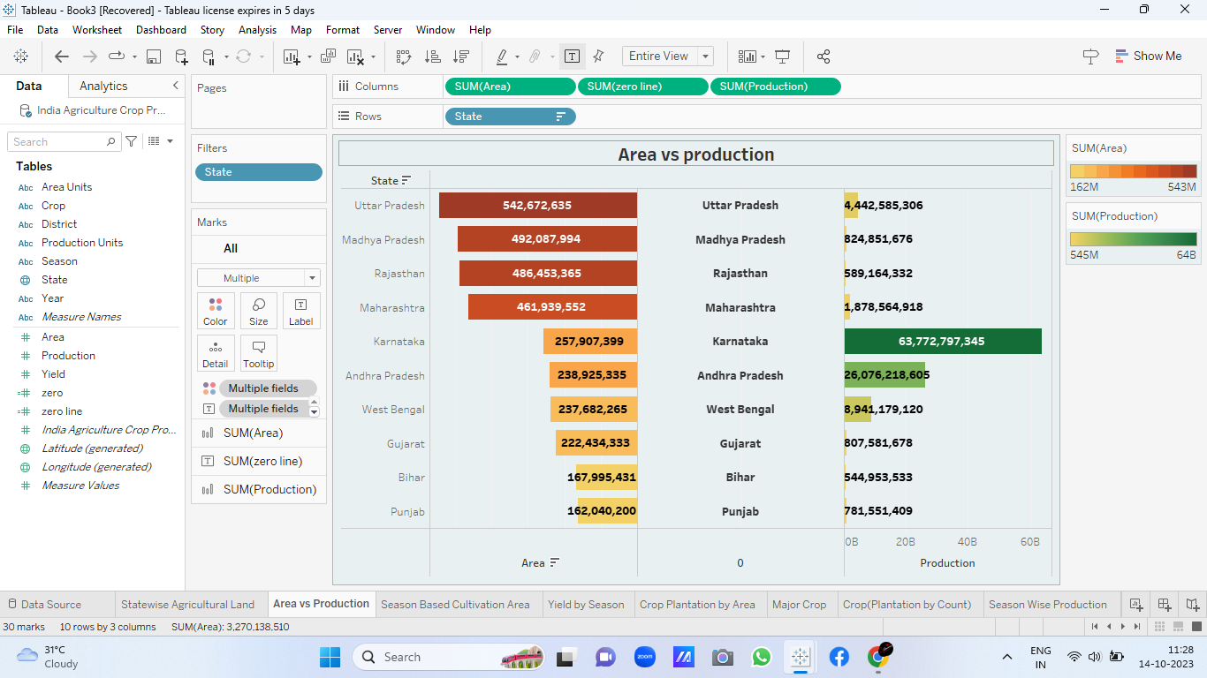

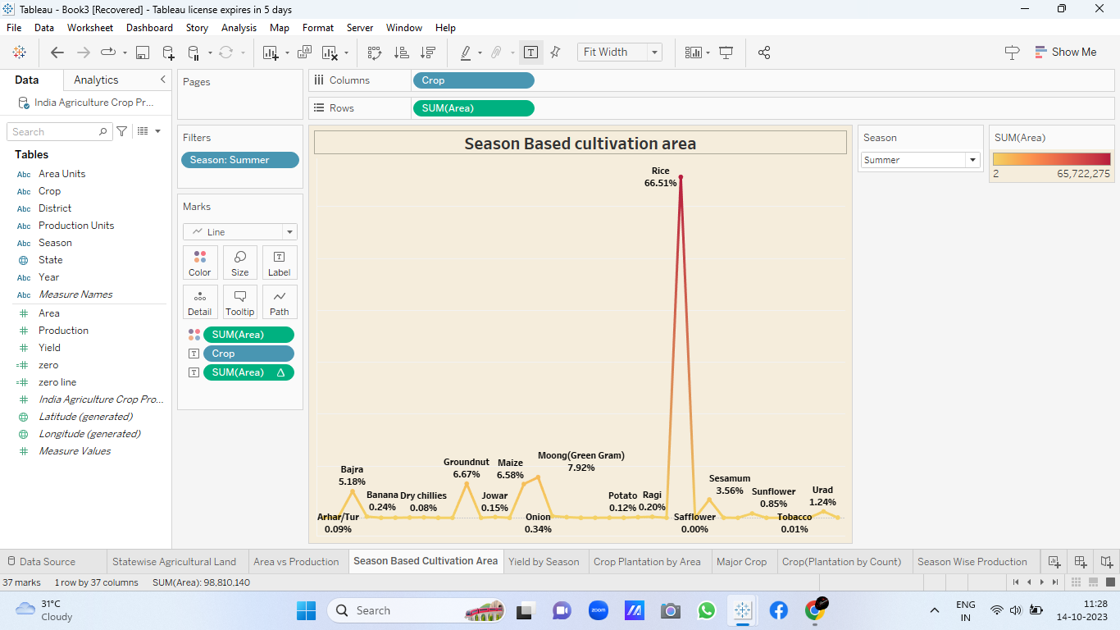

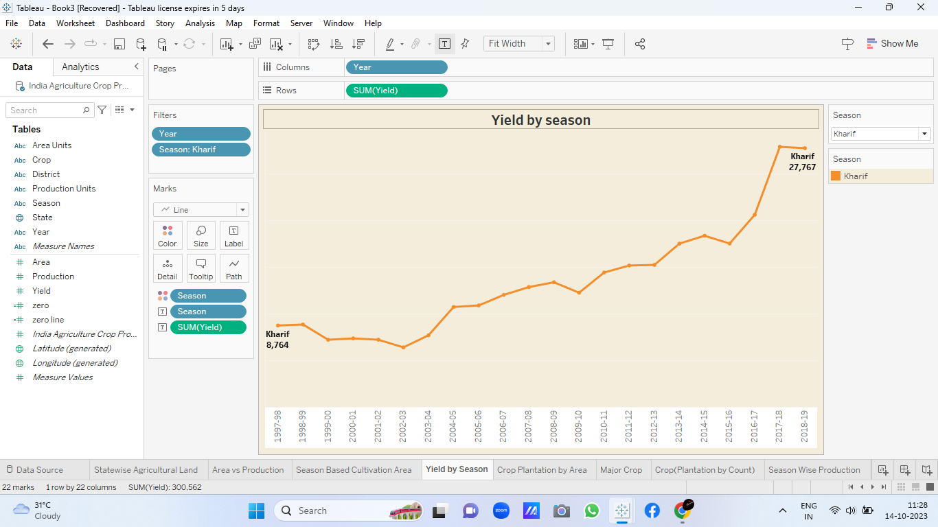

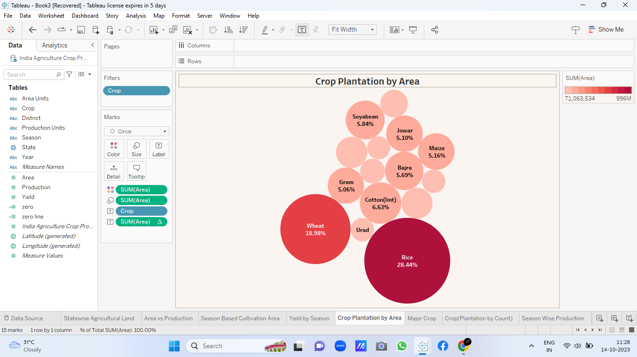

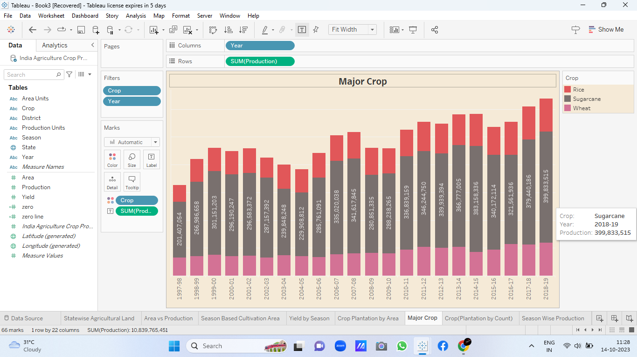

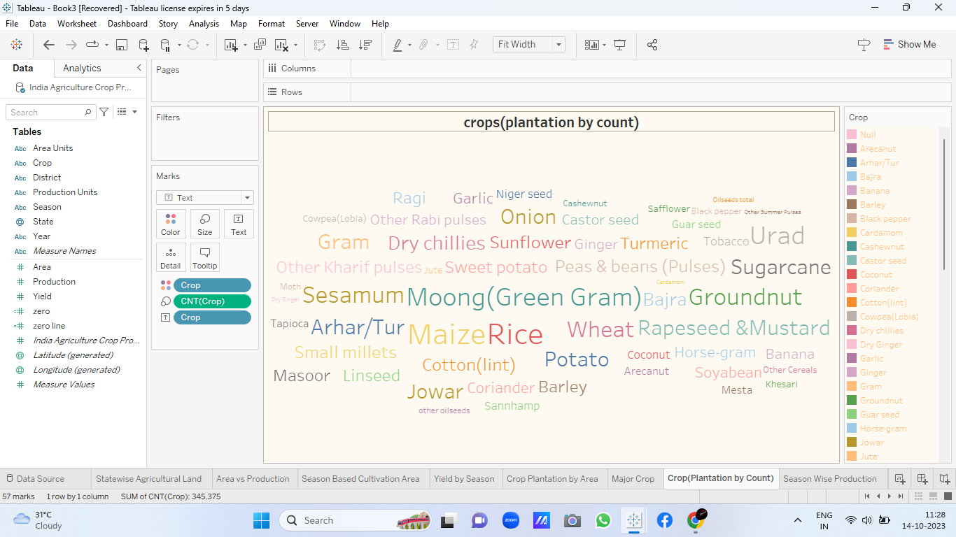

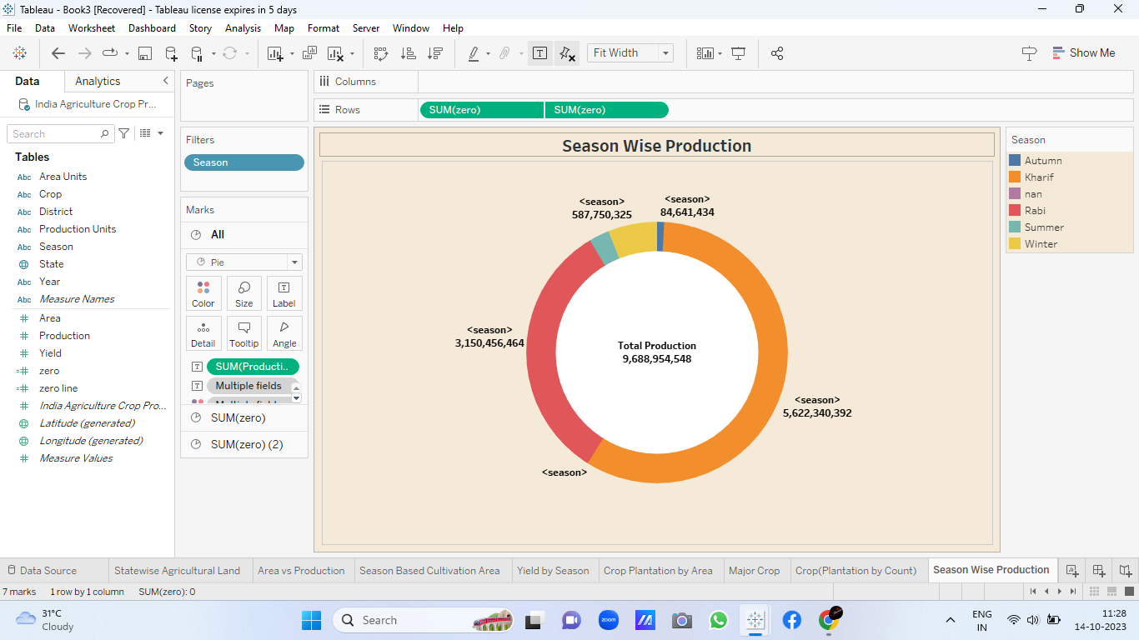

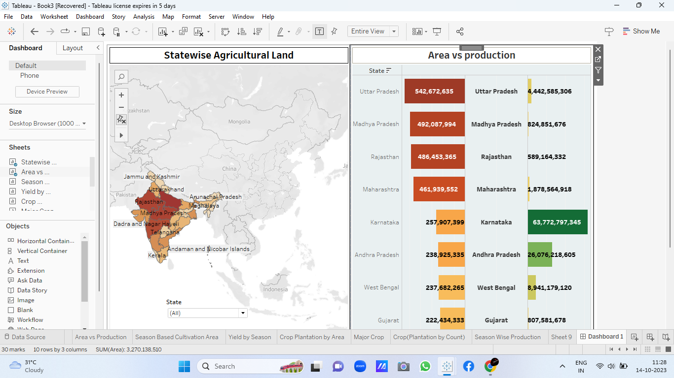

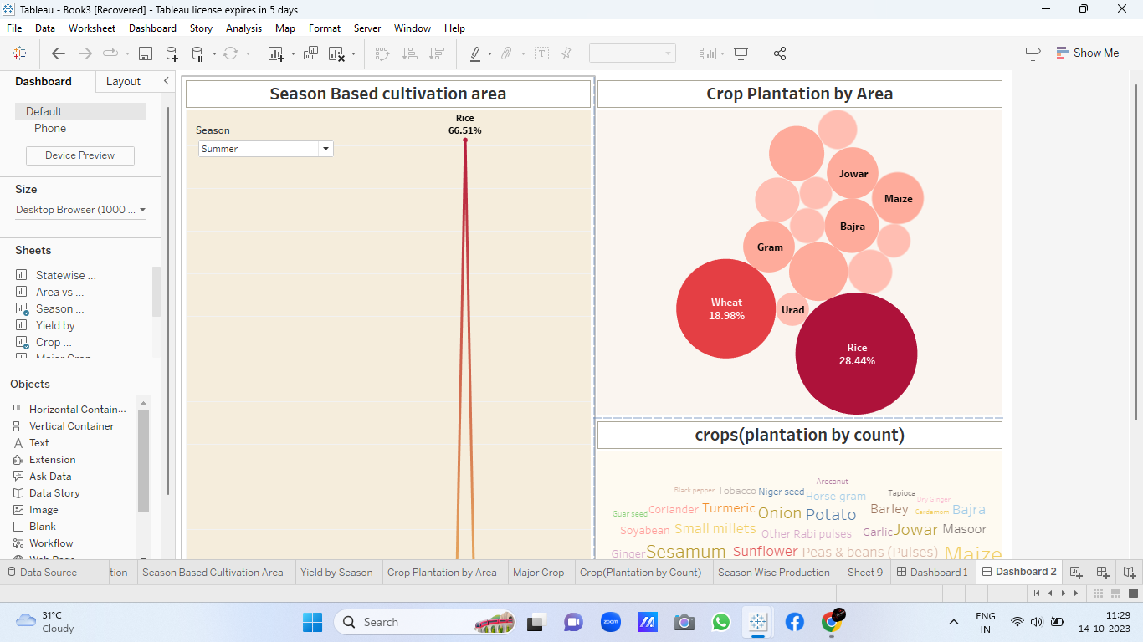

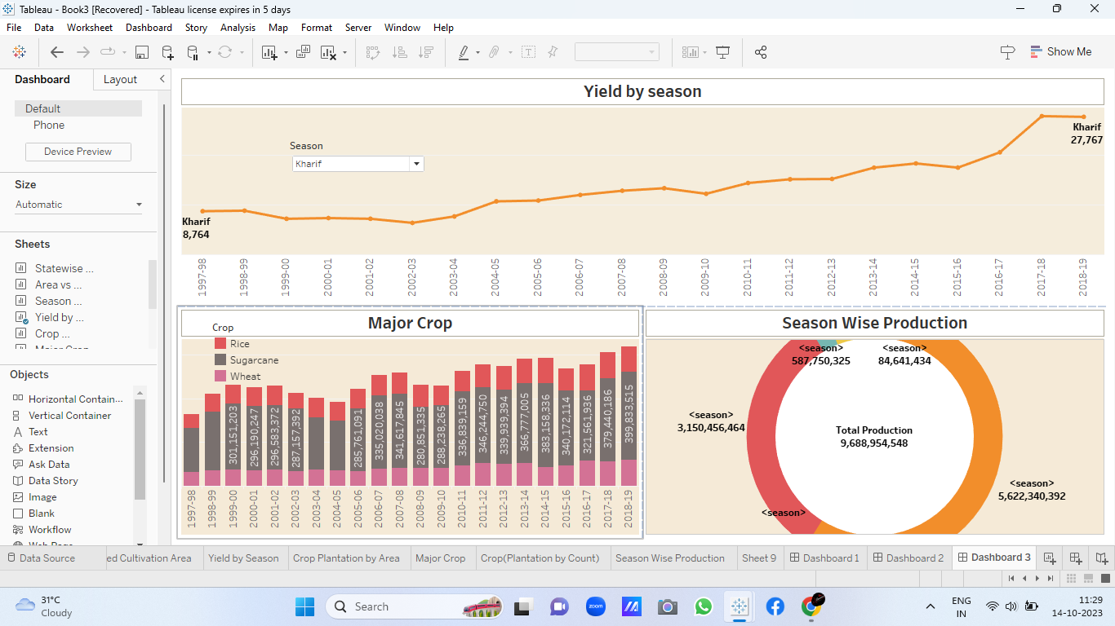

1. **ADVANTADES & DISADVANTAGES**

**Advantages**

* **Food Production:** Agriculture is the primary source of food for the world’s population. It provides us with fruits, vegetables, grains, meat, and dairy products that are essential **for a** healthy diet.
* **Employment:** Agriculture provides employment opportunities for millions of people worldwide. From farmers and farmworkers to scientists and engineers, agriculture is a vast industry that requires a variety of skilled professionals.

**Disadvantages**

* **Environmental Degradation:** Agriculture can cause environmental degradation. Overuse of fertilizers and pesticides can contaminate soil and water resources, while land clearing can destroy natural habitats and wildlife.
* **Land Use Issues:** Agriculture requires large amounts of land, which can lead to conflicts with other land uses, such as residential or commercial development. This can also result in the loss of natural habitats and open space.

1. **APPLICATION**

This report delves into the captivating realm of India's agricultural cultivation, providing a comprehensive visual exploration of key aspects and trends in the agricultural sector. Through the visual representations, readers can gain valuable insights into crop production, seasonal variations, regional distribution, and overall production trends.

1. **CONCLUSION**

The agricultural sector is of vital importance for the region. It is undergoing a process of transition to a market economy, with substantial changes in the social, legal, structural, productive and supply set-ups, as is the case with all other sectors economy.

**7 FUTURE SCOPE**

The stark observation made in the [Economic Survey of 2015-16](http://indiabudget.nic.in/survey.asp) that “Indian agriculture, is in a way, a victim of its own past success – especially the green revolution”, shows the dark reality of the agriculture sector at present and the havoc that has been wreaked by the green revolution.